Task

Vpc1-stockholm

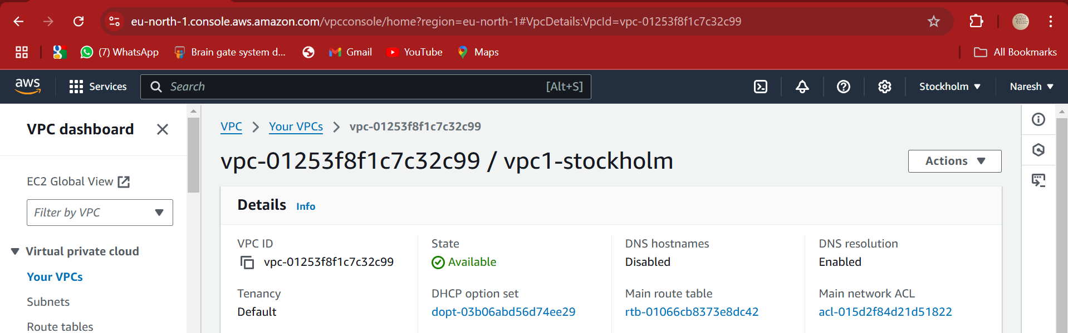

VPC2-virginia

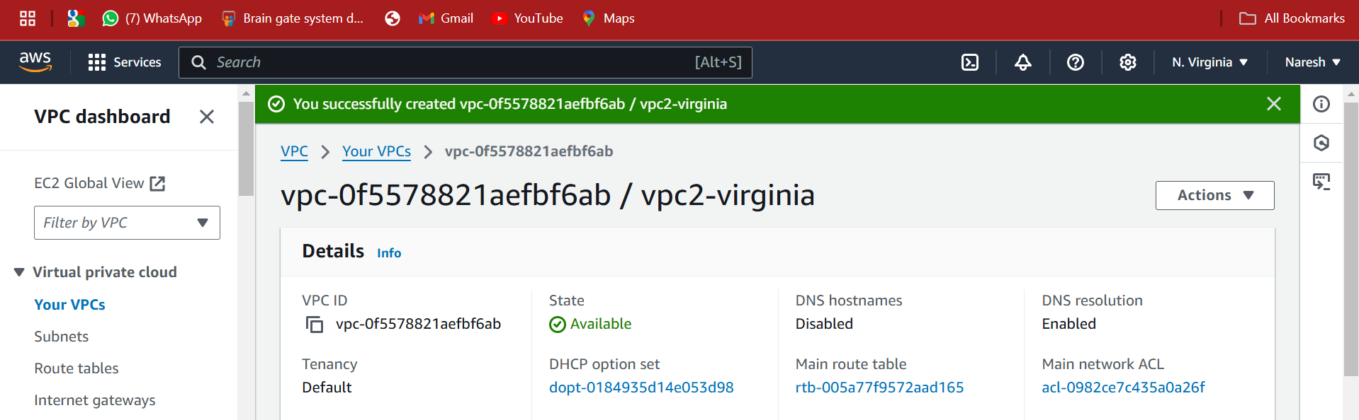

VPC3-sydney

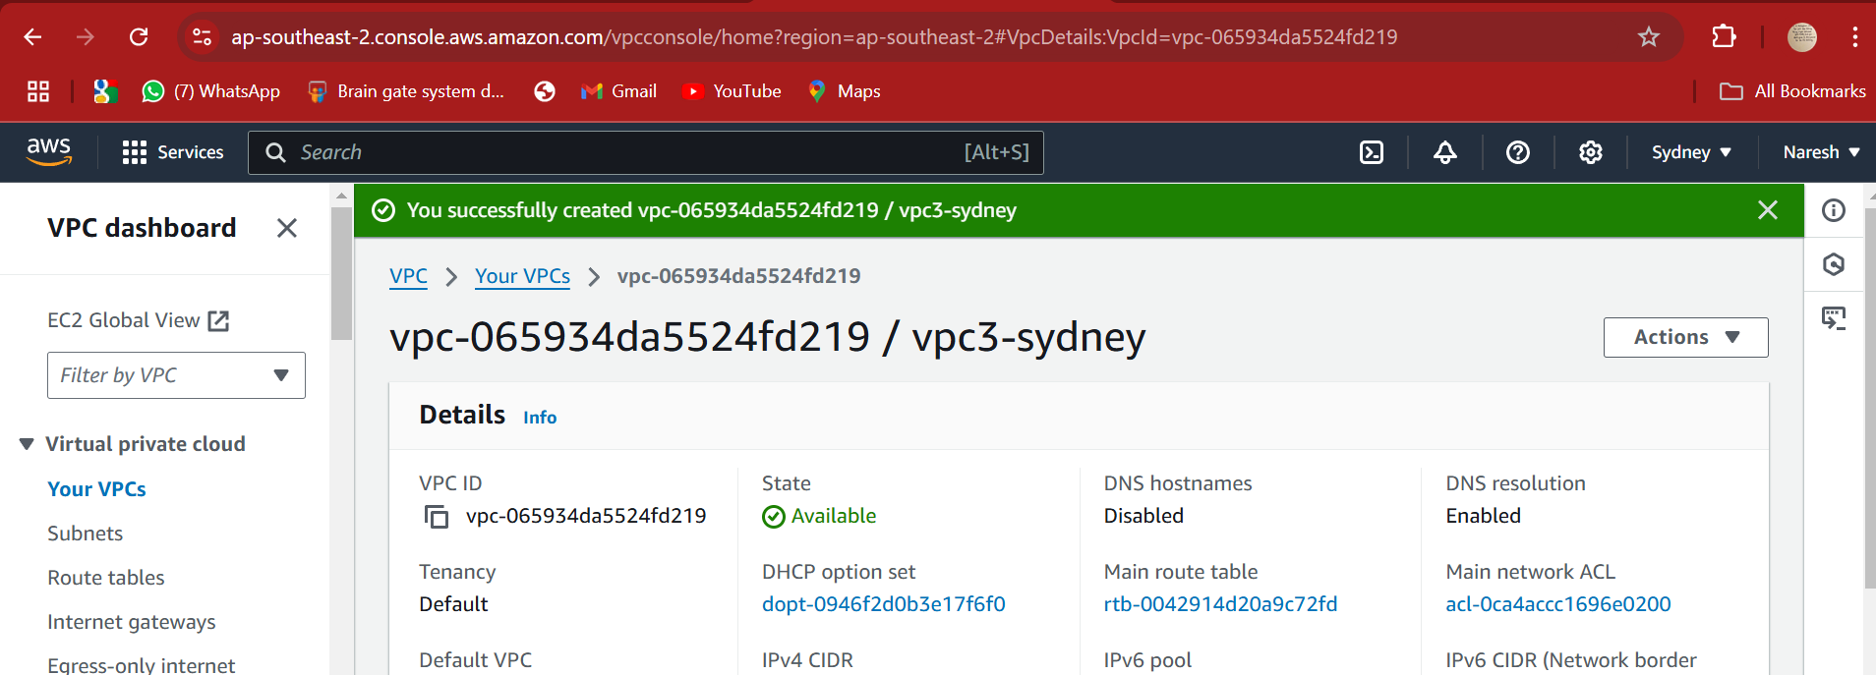

VPC4-mumbai

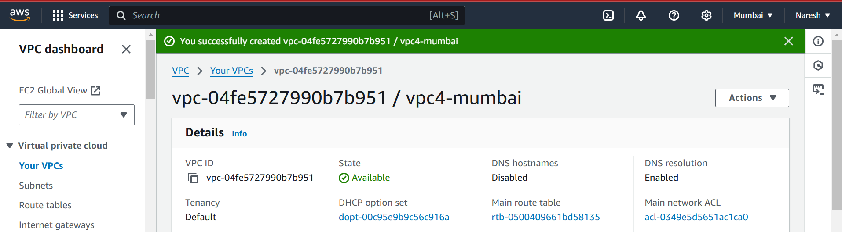

Subnet1

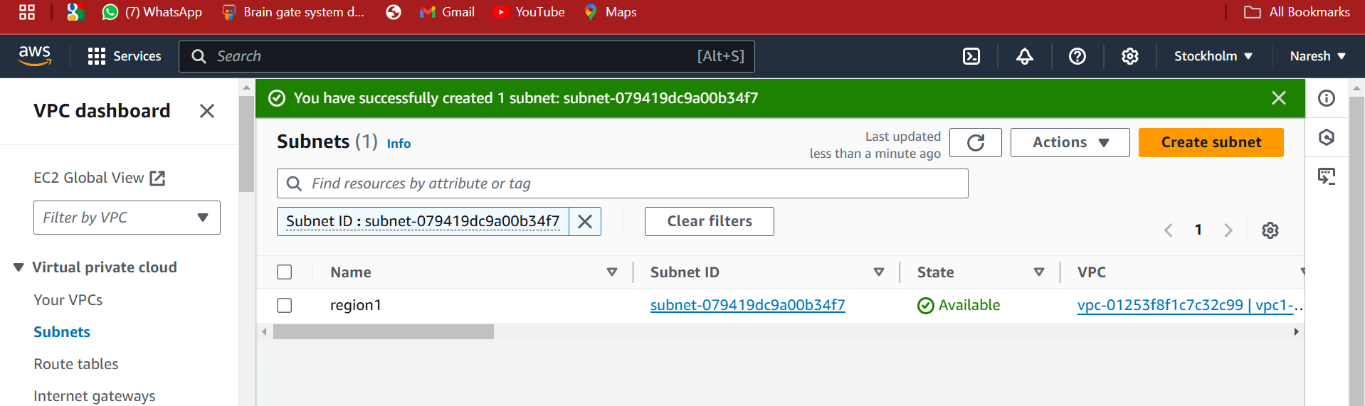

Subnet2

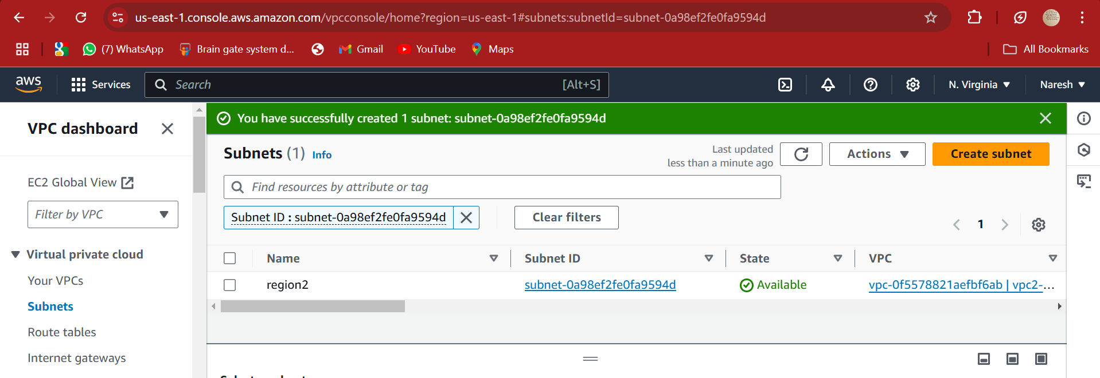

Subnet3

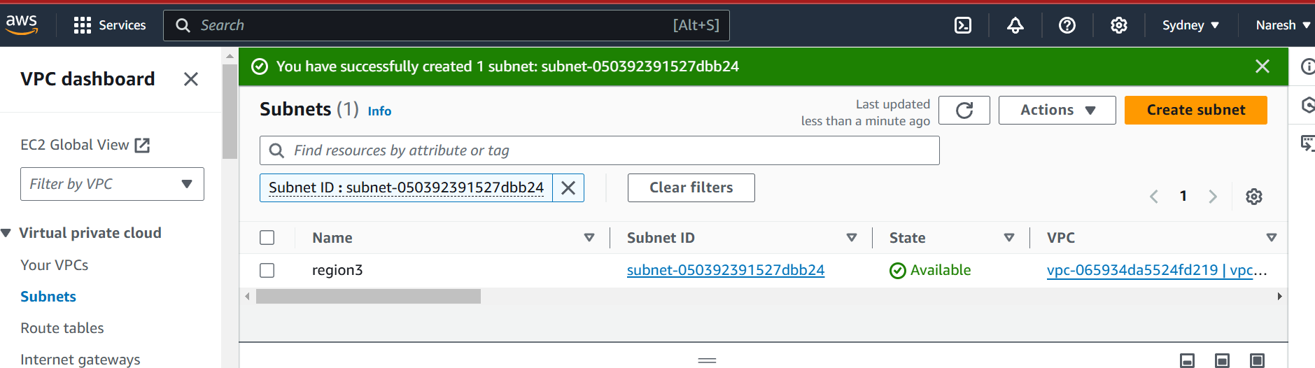

Subnet4

